* **P2P cycle**

The Procure to Pay (P2P) cycle is the comprehensive process within an organization, covering requisition, purchase order issuance, goods receipt, invoice verification, and payment, to efficiently acquire goods and services.

3 way match is made between PO, GR, IR

Determination of requirements

The process of creating a formal

request for goods or services.

within a business.

The document issued to a supplier,

formalizing the intent to purchase

or services.

Payment Processing

Invoice Verification

Goods receipt

Purchase order monitoring.

Order Processing (PR)

Vendor selection

Determination of source to supply.

The acknowledgment of received.

goods or services, confirming delivery

against the purchase order.

The validation and approval process

for supplier invoices, ensuring.

accuracy and compliance.

* **Why p2p cycle is important?**

A P2P process helps organizations manage their spending and reduce costs. It can also help you save costs by reducing manual and laborious tasks.

Besides these, here are some reasons why a P2P process is important:

* Streamlines the procurement process by clearly defining all the necessary actions.
* Allows buyers and suppliers to keep track of [invoices](https://cleartax.in/g/terms/invoice?__hstc=173961468.76b55bb0355938a6daf5447b26741eef.1712997975591.1712997975591.1712997975591.1&__hssc=173961468.1.1712997975592&__hsfp=1003488050) and the payment progress.
* Strengthens relationships with suppliers by ensuring timely payment and resolving issues promptly.
* Prevents mistakes such as duplicate orders, overpaying, and payment errors

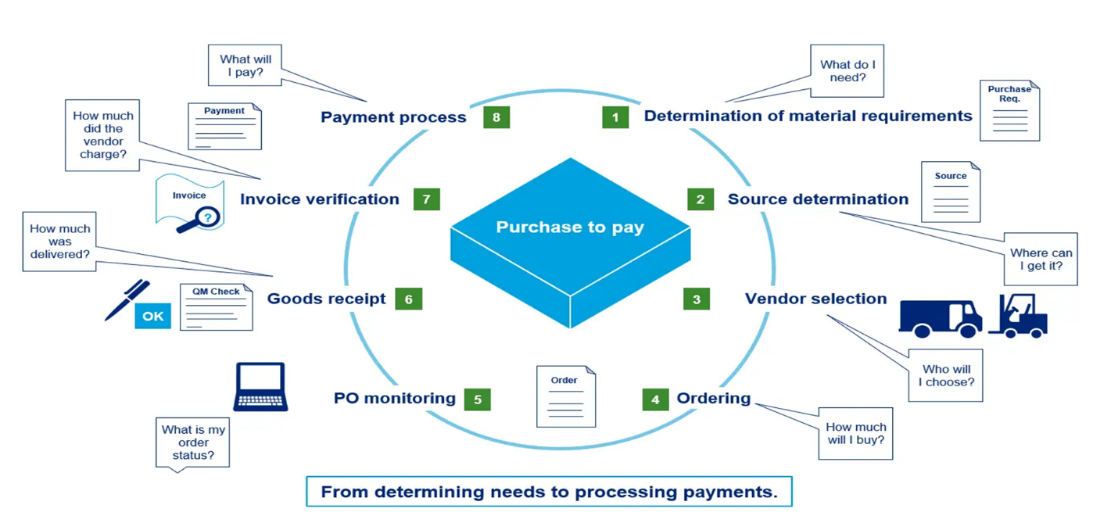

* **Benefits of p2p cycle**
* Cost-Savings: Streamlining the P2P process reduces operational costs associated with manual tasks, errors, and delays.
* Time-saving: Automating repetitive tasks, such as data entry and invoice matching, allows employees to focus on more strategic activities.
* Strategic Decision-Making: Companies can use the data and insights gathered from the P2P process to make informed decisions about supplier selection, contract negotiations, and sourcing strategies.
* Improved Vendor Management: An efficient P2P process streamlines a company’s vendor management processes by helping you shortlist vendors quickly, negotiate prices, and track their performance.
* Customer Satisfaction: Streamlined procurement processes ensure that goods and services are readily available, which, in turn, helps meet customer demand and improve satisfaction.
* Competitive Advantage: Companies with an efficient P2P process can respond more quickly to market changes and opportunities, gaining a competitive edge.
* **3-Way Match:**

The 3-way matching process is a crucial step in the P2P cycle. It ensures accurate payments and prevents overspending or duplicate payments.

Here’s how it works:

* Purchase Order (PO): When an organization needs goods or services, they create a purchase order. The PO captures details such as the buyer’s name, date, specific supplies, quantities, prices, and a unique PO number.
* Receiving Reports or Goods Received Notes (GRNs): When the supplier delivers the goods, they provide an order number. The GRNs detail what’s included in the order and confirm receipt.
* Supplier’s Invoice: The vendor sends an invoice requesting payment for the delivered goods.

Matching Process: The accounts payable department verifies the supplier’s invoice by comparing it to:

* The original purchase order: Ensures the price and quantity match the agreed terms.
* The receiving documentation (GRNs): Verifies that the goods were received in proper condition and match the quantities specified in the purchase order.
* The invoice itself: Reviewed for accuracy and completeness.

The goal is to prevent overspending and ensure authorized purchases are paid for.

* **2-Way Match:**

In contrast, the 2-way matching process focuses on two documents:

* Purchase Order (PO): Compares the information in the supplier’s invoice to the PO initially sent during ordering.
* Supplier’s Invoice: Ensures alignment between the invoice and the PO.

The 2-way match doesn’t involve the receiving documentation (GRNs) like the 3-way match does.

In summary:

* 3-way match: Verifies invoice, PO, and GRNs to ensure accurate payment.
* 2-way match: Compares invoice and PO without involving GRNs.
* **T-codes for p2p cycle:**

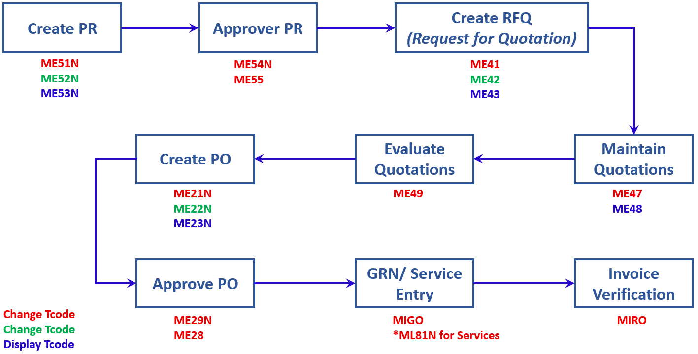

* **Order to Cash (O2C):**

O2C encompasses the end-to-end process by which a company receives, manages, and fulfills customer orders while ensuring timely payment.

Key Steps in O2C:

* Customer Order Placement: The cycle begins when a customer places an order for products or services.
* Order Fulfillment: The business swings into action, preparing goods for shipment or scheduling service appointments to meet customer needs promptly.
* Order Shipment: The ordered goods are carefully packaged and dispatched to the customer’s designated location.
* [Invoice Generation and Delivery: Following successful delivery, the business generates a detailed invoice reflecting agreed-upon pricing and terms](https://www.highradius.com/resources/Blog/order-to-cash-vs-procure-to-pay/).
* **Key Differences:**
* Focus:
  + O2C: Primarily focuses on managing customer orders and cash inflow.
  + P2P: Primarily focuses on sourcing, purchasing, and payment for goods and services.
* Direction:
* O2C: Customer-centric (from order placement to payment collection).
* P2P: Organization-centric (from requisition to payment).
* Purpose:
* O2C: Ensures efficient customer order fulfillment and cash flow management.
* P2P: Ensures efficient procurement and vendor payment processes.

[Both cycles are integral to optimizing business operations, enhancing relationships, and ensuring financial efficiency](https://www.highradius.com/resources/Blog/order-to-cash-vs-procure-to-pay/)